­­­­Supporting Information for

**Oceanic constraints on future Eurasian winter surface air temperature changes**

**Anqi Liu1, Daokai Xue1, Xiaolong Chen2*, Danqing Huang1\***

1 School of Atmospheric Sciences, Nanjing University, Nanjing 210023, China

2 State Key Laboratory of Numerical Modeling for Atmospheric Sciences and Geophysical Fluid Dynamics, Institute of Atmospheric Physics, Chinese Academy of Sciences, Beijing, China

Submitted to Environmental Research Letters

*Corresponding author:

Prof. Danqing Huang ([huangdq@nju.edu.cn](mailto:huangdq@nju.edu.cn))

Prof. Xiaolong Chen (chenxiaolong@mail.iap.ac.cn)

**Table S1** List of the 36 CMIP6 Models Used in This Study

|  |  |  |  |  |
| --- | --- | --- | --- | --- |
| Model Number | Model Name | Modeling center and country | Atmospheric; oceanic resolution (lon × lat: number of grids, L: vertical levels) | Number of  Members |
| 1 | ACCESS-CM2 | Commonwealth Scientific and Industrial Research Organization and Bureau of Meteorology, Australia | 192 x 144/L85 ;360 x 300/L50 | 5 |
| 2 | ACCESS-ESM1-5 | 192 x 145/L38 ;360 x 300/L50 | 40 |
| 3 | AWI-ESM-1-1-LR | Alfred Wegener Institute, Helmholtz Centre for Polar and Marine Research, Germany | 384 x 192/L95 ; 830305 wet nodes/L46 | 1 |
| 4 | BCC-CSM2-MR | Beijing Climate Center, China Meteorological Administration, China | 320 x 160/L46 ;360 x 232/L40 | 1 |
| 5 | CanESM5 | Canadian Centre for Climate Modelling and Analysis, Canada | 128 x 64/L49 ;361 x 290/L45 | 1 |
| 6 | CanESM5-1 | 128 x 64/L49 ;361 x 290/L45 | 20 |
| 7 | CanESM5-CanOE | 128 x 64/L49 ;361 x 290/L45 | 3 |
| 8 | CAS-ESM2-0 | Chinese Academy of Sciences, Beijing 100029, China | 256 x 128/L35 ; 362 x 196/L30 | 1 |
| 9 | CESM2-WACCM | National Center for Atmospheric Research, USA | 288 x 192/L70 ;320x384/L60 | 1 |
| 10 | CMCC-CM2-SR5 | Fondazione Centro Euro-Mediterraneo sui Cambiamenti Climatici, Italy | 288 x 192/L30 ;362 x 292/L50 | 1 |
| 11 | CMCC-ESM2 | 288 x 192/L30 ;362 x 292/L50 | 1 |
| 12 | EC-Earth3 | 512 x 256/L91 ;362 x 292/L75 | 5 |
| 13 | EC-Earth3-CC | AEMET, Spain; BSC, Spain; CNR-ISAC, Italy; DMI, Denmark; ENEA, Italy; FMI, Finland; Geomar, Germany; ICHEC, Ireland; ICTP, Italy; IDL, Portugal; IMAU, The Netherlands; IPMA, Portugal; KIT, Karlsruhe, Germany; KNMI, The Netherlands; Lund University, Sweden; Met Eireann, Ireland; NLeSC, The Netherlands; NTNU, Norway; Oxford University, UK; surfSARA, The Netherlands; SMHI, Sweden; Stockholm University, Sweden; Unite ASTR, Belgium; University College Dublin, Ireland; University of Bergen, Norway; University of Copenhagen, Denmark; University of Helsinki, Finland; University of Santiago de Compostela, Spain; Uppsala University, Sweden; Utrecht University, The Netherlands; Vrije Universiteit Amsterdam, the Netherlands; Wageningen University, The Netherlands. | 512 x 256/L91 ;362 x 292/L75 | 5 |
| 14 | EC-Earth3-Veg | 512 x 256/L91 ;362 x 292/L75 | 1 |
| 15 | EC-Earth3-Veg-LR | 320 x 160/L62 ;362 x 292/L75 | 3 |
| 16 | FGOALS-f3-L | Chinese Academy of Sciences, China | 360 x 180/L32 ;360 x 218/L30 | 1 |
| 17 | FGOALS-g3 | 180 x 90/L26 ;360 x 218/L30 | 1 |
| 18 | FIO-ESM-2-0 | FIO (First Institute of Oceanography, China), QNLM (Qingdao National Laboratory for Marine Science and Technology, China) | 192 x 288/L26 ;320 x 384/L60 | 3 |
| 19 | GFDL-ESM4 | National Oceanic and Atmospheric Administration, Geophysical Fluid Dynamics Laboratory, USA | 360 x 180/L49 ;720 x 576/L75 | 3 |
| 20 | GISS-E2-1-G | Goddard Institute for Space Studies, New York, NY 10025, USA | 144 x 90/L40 ;360 x 180/L60 | 11 |
| 21 | GISS-E2-1-H | 144 x 90/L40 ;360 x 180/L60 | 5 |
| 22 | GISS-E2-2-G | 144 x 90/L102 ;360 x 180/L40 | 5 |
| 23 | INM-CM4-8 | Institute for Numerical Mathematics, Russia | 180 x 120/L21 ;360 x 318/L40 | 1 |
| 24 | INM-CM5-0 | 180 x 120/L73 ;720 x 720/L40 | 1 |
| 25 | IPSL-CM6A-LR | Institut Pierre Simon Laplace, France | 144 x 143/L79 ;362 x 332/L75 | 7 |
| 26 | KIOST-ESM | Korea Institute of Ocean Science & Technology, Republic of Korea | 192 x 96/L32 ;360 x 200/L52 | 1 |
| 27 | MIROC6 | JAMSTEC (Japan Agency for Marine-Earth Science and Technology, Japan), AORI (Atmosphere and Ocean Research Institute, Japan), NIES (National Institute for Environmental Studies, Japan), and R-CCS (RIKEN Center for Computational Science, Japan) | 256 x 128/L81 ;360 x 256/L63 | 50 |
| 28 | MIROC-ES2H | 256 x 128/L81 ;360 x 256/L63 | 3 |
| 29 | MIROC-ES2L | 128 x 64/L40 ;360 x 256/L63 | 30 |
| 30 | MPI-ESM1-2-HR | Max Planck Institute for Meteorology, Hamburg 20146, Germany | 384 x 192/L95 ; 802 x 404/L40 | 2 |
| 31 | MPI-ESM1-2-LR | 192 x 96 /L47 ; 256 x 220/L40 | 30 |
| 32 | MRI-ESM2-0 | Meteorological Research Institute, Japan | 320 x 160/L80 ;320 x 160/L61 | 1 |
| 33 | NESM3 | Nanjing University of Information Science and Technology, China | 192 x 96/L47 ;384 x 362/L46 | 1 |
| 34 | NorESM2-LM | NorESM Climate modeling Consortium consisting of CICERO (Center for International Climate and Environmental Research, Oslo 0349), MET-Norway (Norwegian Meteorological Institute, Oslo 0313), NERSC (Nansen Environmental and Remote Sensing Center, Bergen 5006), NILU (Norwegian Institute for Air Research, Kjeller 2027), UiB (University of Bergen, Bergen 5007), UiO (University of Oslo, Oslo 0313) and UNI (Uni Research, Bergen 5008), Norway. Mailing address: NCC, c/o MET-Norway, Henrik Mohns plass 1, Oslo 0313, Norway" | 144 x 96/L32 ;360 x 384/L70 | 1 |
| 35 | NorESM2-MM | 288 x 192/L32 ;360 x 384/L70 | 1 |
| 36 | TaiESM1 | Research Center for Environmental Changes, Academia Sinica, Taiwan, China | 288 x 192/L30 ;320 x384/L60 | 1 |

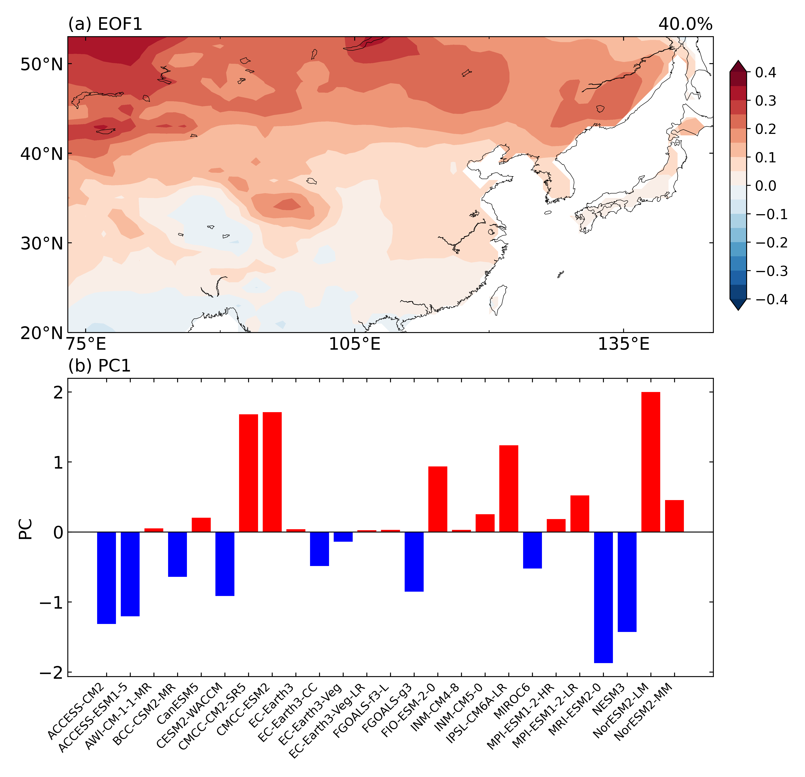

Figure S 1 Same as **Fig** **1**, but using data from the ensemble r1i1p1f1 for the historical run and SSP5-8.5 scenario.

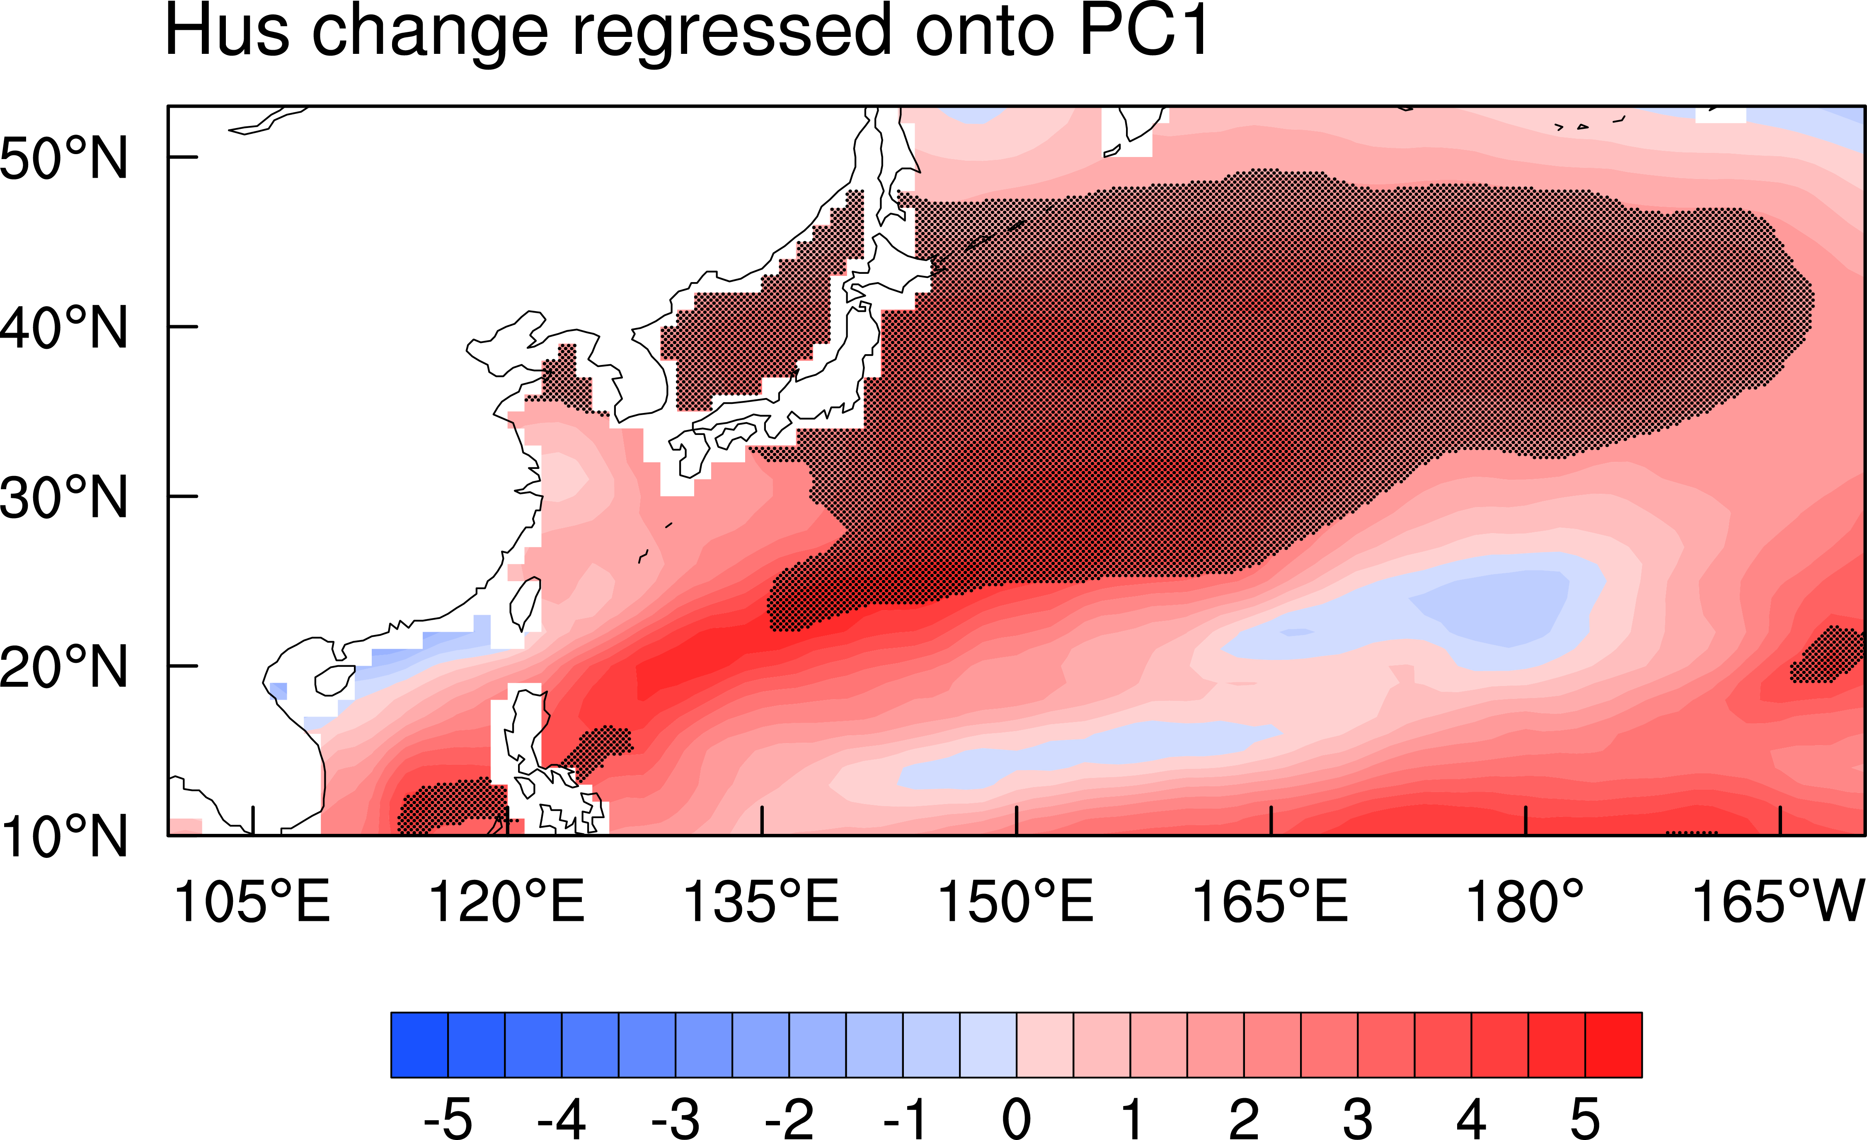

Figure S2 Same as Fig.3, but for specific humidity change ().

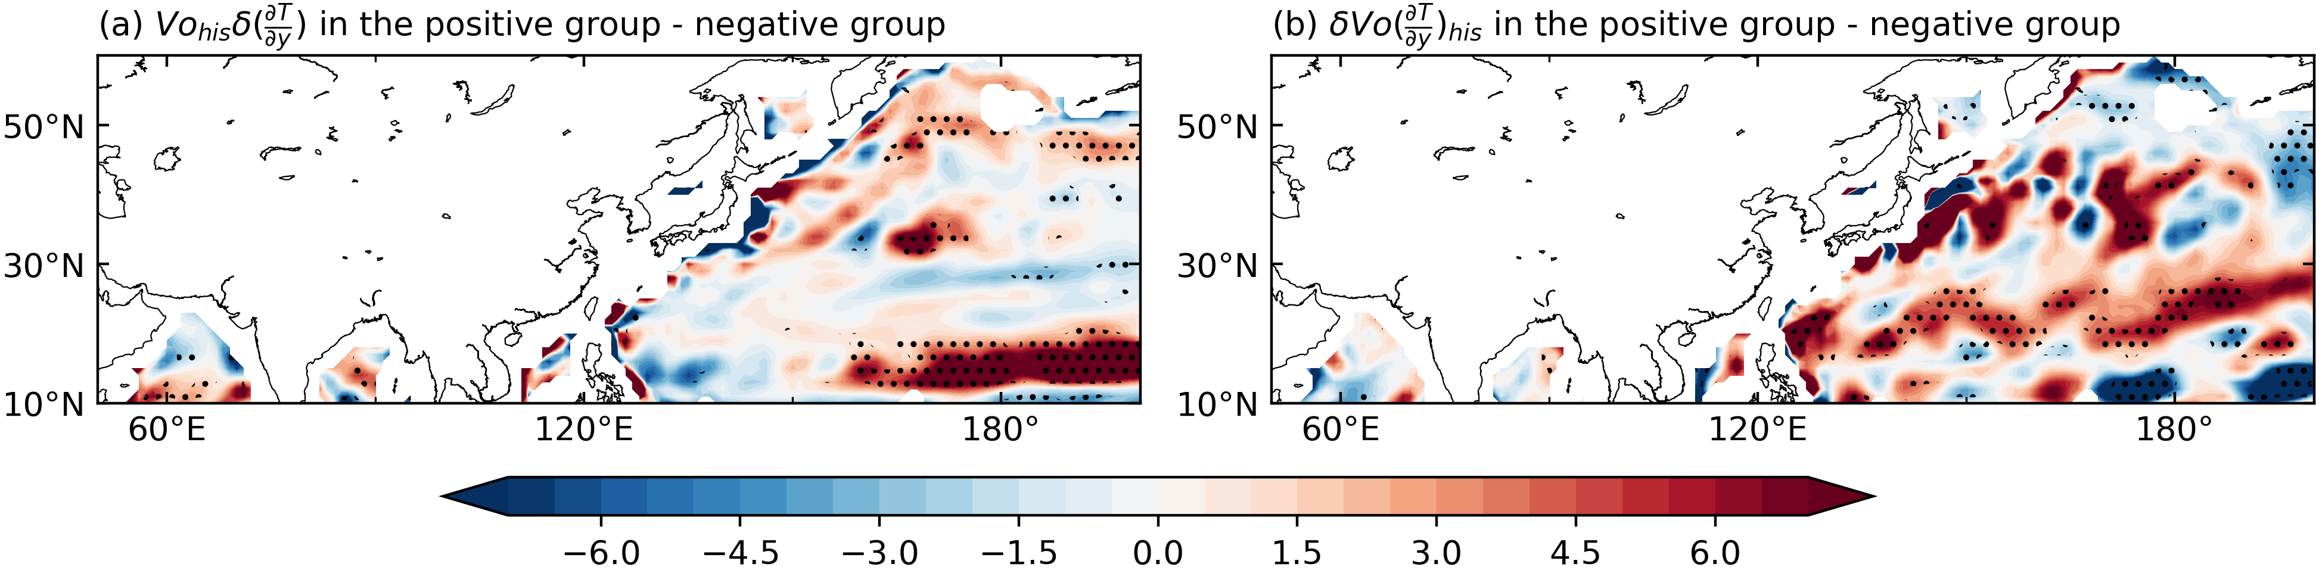

Figure S3 Same as Fig.5d, but for (a) contribution of meridional temperature gradient changes () and (b) contribution of meridional ocean current velocity changes () ().